Type the Main Title of the Paper

- Type the Subtitle of the Paper -

**Main author’s Name 1)  Co-author’s Name 2)**

*1) Society of Automotive Engineers, Inc., Chiyoda, Tokyo, Japan*

*E-mail: taro@jsae.or.jp*

*2) JSAE University, Graduate School of Engineering, Chiyoda, Tokyo, Japan*

*E-mail: taro@jsae.or.jp*

**ABSTRACT**: This document is a common template for the **extended summary and final paper**. **The minimum length of the extended summary is two (2) pages and the maximum length is four (4) pages** including references. **The extended summary should include at least one figure. The final paper should be more than four (4) pages within the eight-page limit.** Use 16 points Times New Roman for main title. Use 11 points for sub-title and author’s name. Use 9 points for author’s affiliation, e-mail address, and the abstract. Top and bottom margins are 25 mm and both sides are 18 mm. Use 9 points for chapters and text. The margin between two columns is 8 mm.

**KEY WORDS**: page, font, style, figure, table, reference

**1. Introduction**

Use 9 points for the main text. Clearly describe the purpose, content, and conclusions of the research, while complying with the ethical guidelines of the JSAE. Company and product names, terminology whose usage is restricted to within a particular company, and commercial content may not be included in the main text.

Note for “References” is indicated in “REFERENCES” as below.(1)

**2. SECTION TITLE**

**2.1. Subheading**

Use 9 points for the main text. Clearly describe the purpose, content, and conclusions of the research, while complying with the ethical guidelines of the JSAE. Company and product names, terminology whose usage is restricted to within a particular company, and commercial content may not be included in the main text.

**2.2. Subheading**

Type the contents of the section here.

**2.2.1. Sub-subheading**

Type the contents of the section here.

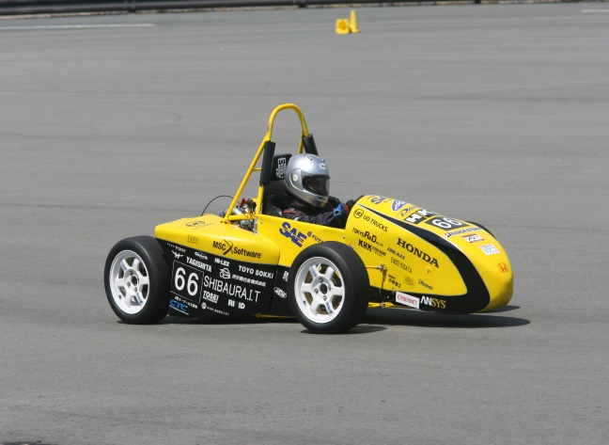

Fig. 1 Type the Caption Here. Font size is 9 point.

**3. SECTION TITLE**

**3.1. Subheading**

Table 1 Type the Caption Here. Font size is 9 point.





Fig. 2 A Bar Graph

**4. CONCLUSIONS**

**ACKNOWLEDGMENT**

**References**

(1) A. Author, B. Author, and C. Author, “Title of Journal or Transaction Paper,” *Name of Journal or Transactions*, vol. 5, no. 12, pp. 12-15, May 2017.

(2) A. Author and B. Author, “Title of Paper in Conference Proceedings,” *Name of Conference Proceedings*, pp. 12-15, Yokohama, Japan, May 25-27, 2016.

(3) A. Author, *Title of Book*, Name of Publisher, 2018.

(4) C. Author. “Title of Website.” Name of Organization. https://www.jsae.or.jp/en/ (accessed May 25, 2020).

(5)

(6)

(7)

(8)

(9)

(10)

(11)

(12)

(13)

(14)

(15)

(16)

(17)

(18)

(19)

(20)